# **Validation Report Cost-Obj**

## *Summary Report*

*OBJECT*

IfcRoof.NOTDEFINED

GlobalId: 2cr5a8oczF5PorVi$sZ3$9

Obj Name: Tetto di base:Latero Cementizio - 27 cm:170917

*COST ITEM*

IfcCostItem

Price List Code: LP.EEA.a04.A1020.Qa000.0035.-

GlobalId: 0_J5mxpN98khPvl_X5nE1p

Cost Name: Wood formwork for slab

*CHART*

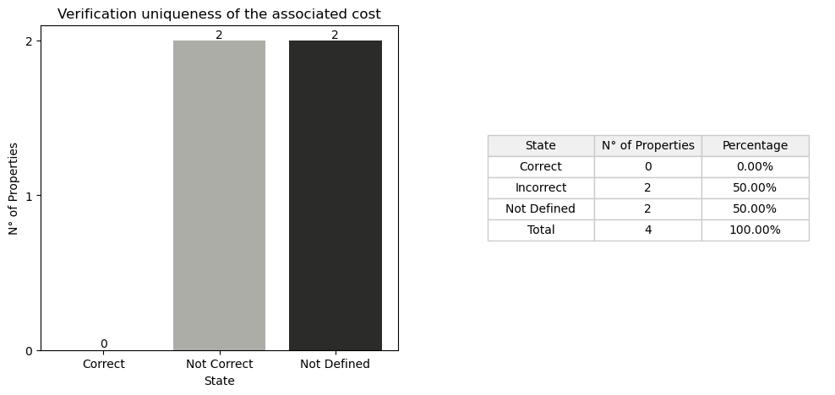

## *Detail Table*

|  |  |  |
| --- | --- | --- |
| **State** | **N° of Properties** | **Properties** |
| Correct | 0 |  |
| Incorrect | 2 | Entity TypeEnum |
| Not Defined in the obj | 2 | Status ConstructionMethod |
| Not Defined in the cost | 0 |  |
| Not Defined in the cost and obj | 0 |  |

## *Detail Report*

**🔸Number of Correct Properties: 0**

**🔸Number of Incorrect Properties: 2**

Entity: ✗   
 • Entity not a Slab  
  
TypeEnum: ✗   
 • Entity not a Slab Floor

**🔸Number of Not Defined Properties in Obj: 2**

Status: ✗   
 • property not found in OBJ  
  
ConstructionMethod: ✗   
 • property not found in OBJ

**🔸Number of Not Defined Properties in Cost Item: 0**

**🔸Number of Not Defined Properties in Cost Item and Obj: 0**